**PROJECT PROPOSAL**

**CHURCH MEMBER EVENT TRACKING SYSTEM**

A Thesis Project Presented to the

Faculty of Datamex College of Saint Adeline, Inc.

In Partial Fulfillment of the Requirements for the

Degree of Bachelor of Science in Information Technology

By:  
Go, Justin Paul T.

**INTRODUCTION**

This chapter introduces the Church Member Event Tracking System, a digital tool for organized and accurate attendance monitoring.The Church Member Event Tracking System is designed to help church leaders manage member records, attendance, and events in a simple and reliable way. Its main purpose is to make record-keeping easier by organizing information in one place and reducing the need for manual paperwork.

Unlike other systems, these focusses only on the essentials. It allows leaders to add and view member profiles, record attendance during events, and keep track of important details without unnecessary complexity. The system is built to work offline on a dedicated desktop or laptop computer, ensuring stability and security even without an internet connection.

As the church grows, keeping track of church members and their participation can get overwhelming, especially as more events are held. When everything is written on paper or saved in different files, things can be hard to manage or even forgotten. It becomes difficult to see who’s actively involved and how often they attend. That’s why having a simple, organized system matters; it makes it easier to follow up, plan better, and stay connected with the church community.

Our main goal is to provide a straightforward system that keeps track of which members attend various church events. We plan to store all attendance and member information in one central, organized place, making the data easy to access whenever it's needed. This system will greatly support our church leaders by giving them accurate records to help plan future events more effectively. We also hope this tool will encourage members to get more involved by allowing us to recognize their active participation. Ultimately, the system will display on-screen summaries and statistics to help the church better understand how members are engaging with the community over time.

**CLIENT INFORMATION** Client Information provides the basic details about the church as the main beneficiary of the system, including its name, location, and key persons involved in the project.

**Name Organization**: Touching Heart Christian Assembly

**Contact Person**: Bishop, Alex

**Location**: Block 9, Lot 36, Barangay 35, Caloocan City

**Contact No**: 0917 153 4813

**Facebook Page**: Touching Heart Christian Assembly

Touching Heart Christian Assembly is a warm and welcoming church where families, youth, and individuals come together to worship, pray, and grow in their faith. The church values strong connections and creates meaningful opportunities through worship services, fellowships, and ministries for all ages. With its growing congregation, it continues to nurture both spiritual growth and community involvement in a caring, organized way.

**Client logo and Establishment**

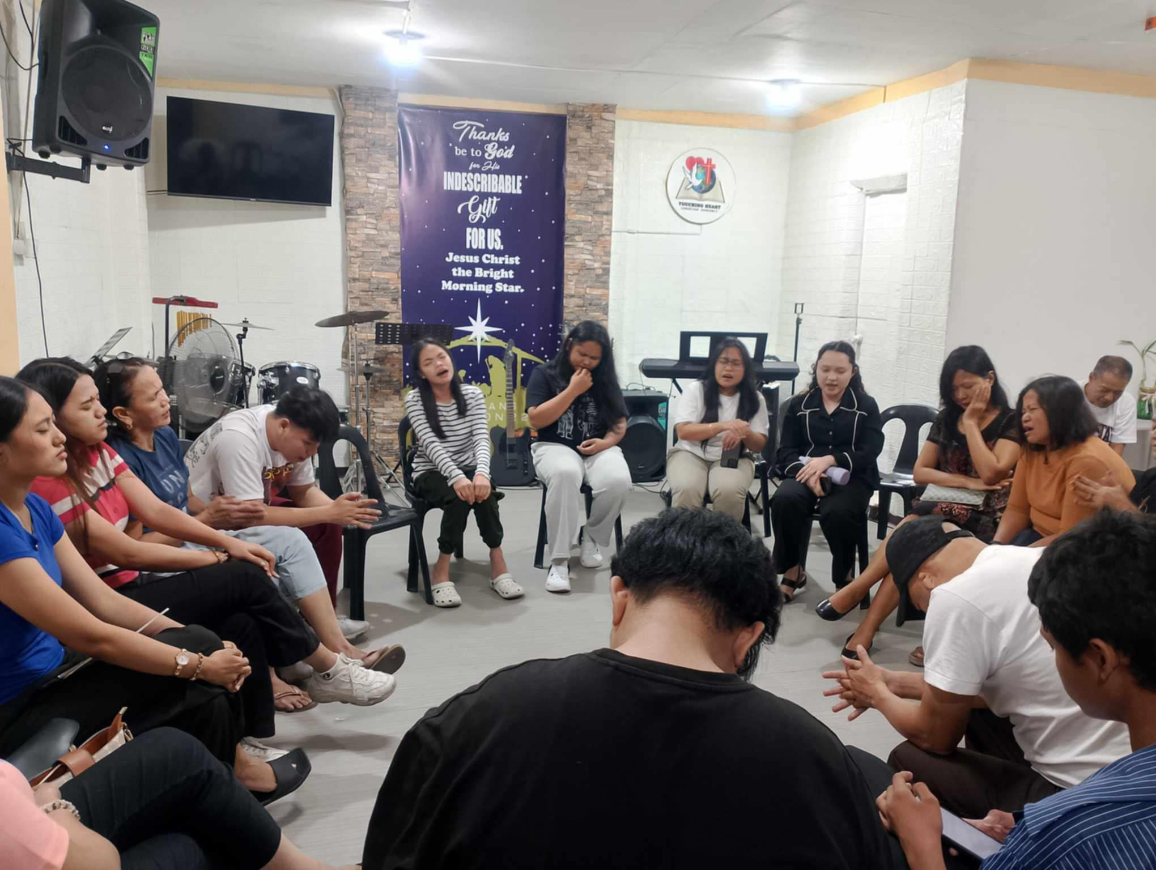

*Figure 1. Client Logo and Establishment*

**PROJECT SCOPE**

This project aims to build a simple and secure church management system that helps leaders record attendance, manage member profiles, and track event participation for more organized and efficient operations.  
  
**Deliverables and Outcomes**

Our system provides church leaders with an easy-to-use digital tool for tracking member attendance and managing individual profiles. It replaces paper-based logs, saving time and reducing manual work. The system also features an on-screen digital ID generation capability and provides accessible on-screen summaries for better planning and coordination of future church activities.  
  
**Inclusion (Covered by the System)**

The system will store and organize basic member information such as names, contact details, and roles in the church. It will allow leaders to manually record attendance during services and events, ensuring that important details are properly documented. Data will be arranged in an organized format so that leaders can easily review records whenever needed. The system will also include simple tools for searching and viewing information, making it easier to monitor church activities. Since it is designed for offline use, records will always remain accessible without requiring an internet connection.  
 **Exclusion (Not Covered by the System)**

The system will not provide individual login access for members, as only leaders are allowed to use it. All attendance and other data must be entered manually because it does not support automated input such as QR code scanning. It will not send SMS, email, or online reminders since it is intended only for offline record-keeping. The system will not be available on mobile phones or tablets and is strictly for use on a desktop or laptop computer. It will also not include social features such as chat or forums, as it is designed solely for administrative purposes. While the generated digital ID card includes a QR code for potential future use, the current version of the system does not include a QR code scanning feature for attendance.  
 **Assumptions**

To make this project successful, we are working with a few important assumptions. Church leaders will be properly guided on how to use the system. Since it is designed to be simple and reliable, it will run completely offline and won’t need an internet connection. All data, such as member profiles and attendance, will be entered manually by authorized users to keep records accurate and organized. Lastly, the church is expected to have a dedicated desktop or laptop that meets the minimum requirements for the system to run smoothly.  
  
**Constraints**

The system will only run on a desktop or laptop computer and is not designed for mobile phones or tablets. It is strictly for internal record-keeping and will not connect to external tools such as email, text messaging, or online platforms. Since attendance is recorded manually, leaders must be careful when inputting data to ensure accuracy. For security purposes, the system is intended for use on one dedicated computer and cannot be accessed remotely or through a network. Access is restricted to authorized leaders only, as it does not support multiple roles for members.

**PROJECT APPROACH**

The Church Member Event Tracking System is designed to help church leaders manage member information, record attendance, and track participation in events through a simple and organized offline system.

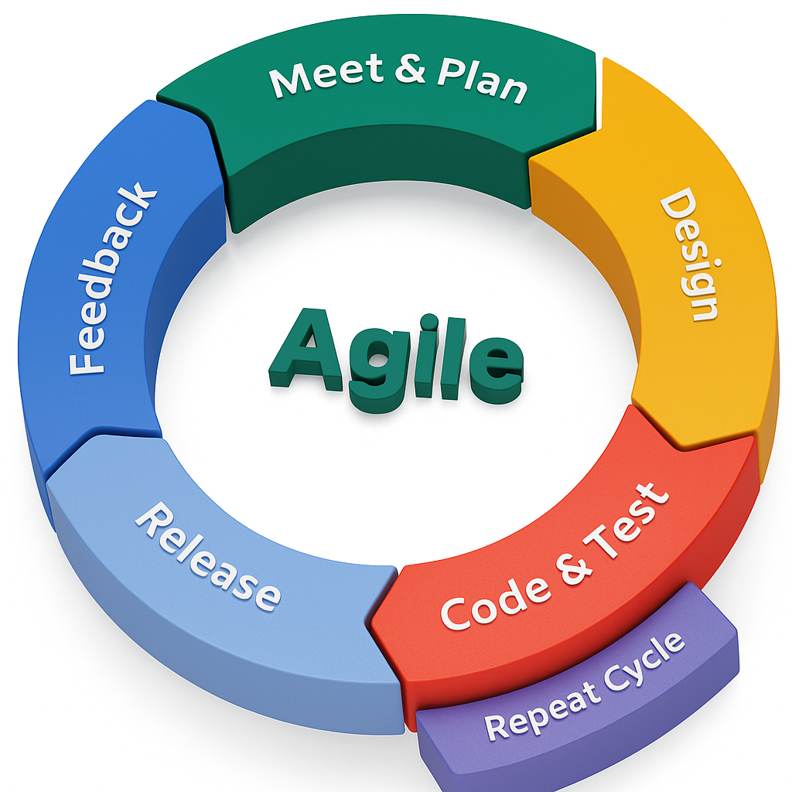**Methodologies and Frameworks to be Used**

*Figure 2. Agile Methodology for Church Member and Event Tracking System*

**Meet & Plan**

At the beginning of each cycle, I will meet with your church leaders to decide on the most important features to build next (for example, member registration or event scheduling). Think of this as my focused Requirements Analysis for the sprint. I'll then break these goals down into small, clear tasks for my project list (the product backlog).

**Design**

Next, I'll jump into the System Design for these specific features. I’ll sketch out simple layouts (wireframes) for the new forms and the layout of on-screen summaries, and I’ll map out how the database will store the information for members, events, and attendance.

**Code & Test**

This is where hands-on System Development happens. I will write the code for the planned features, and at the same time, I'll conduct my initial System Testing to ensure that every new piece works exactly as it should.

**Release & Implementation**

Once the new features are built and tested, it’s time for a mini-release. This is my small-scale Deployment and Implementation. I’ll hand over the working features to your staff so they can start using them in real-world situations and see how they feel.

**Feedback & Maintenance**

This is where I listen. I'll gather feedback from your users: What's working well? Is anything confusing or missing? These valuable insights become part of my ongoing Maintenance and improvement. I’ll take all these great ideas and add them to my list for the next sprint.  
  
**Repeat the Cycle**

And then, I will repeat this entire rhythm: Meet, Design, Code, Release, and get Feedback. I’ll continue this cycle, improving and adding to the system with each sprint, until it is fully built and perfectly fitted to your church's needs.

**PROJECT TIMELINE**

The project for the Church Member Event Tracking System is scheduled for completion over a structured 11-week period. The timeline begins with foundational planning and requirements analysis, followed by system design, core development, and thorough testing. The final weeks are dedicated to deploying the system at the church, completing all necessary documentation, and conducting the final presentation. This step-by-step approach ensures that each phase builds upon the last, leading to a well-developed and successful project delivery.

|  |  |  |  |
| --- | --- | --- | --- |
| **Week** | **Phase / Activity** | **Deliverables** | **Dependencies / Critical Path** |
| Week 1 | Project Planning | Project scope, objectives, and timeline. | Start of project, required before all else. |
| Week 2 | Requirements Analysis | List of features based on interviews with church leaders. | Must be completed before system design begins. |
| Week 3-4 | System Design | UI mockups, database schema, system structure. | Depends on completed requirements analysis. |
| Week 5-7 | System Development | Working system (frontend, backend, database). | Requires finalized design. |
| Week 8 | System Development | Test reports (functional, usability, UAT). | Must follow full system development. |
| Week 9 | Deployment and Implementation | System installed and running in the church office. | Dependent on successful testing phase. |
| Week 10 | Final Documentation | User manual, technical documentation. | Requires full knowledge of the developed system. |
| Week 11 | Final Presentation | System presentation to panel or adviser. | Based on the entire project completion. |

*Table 1. Project Timeline for Church Member and Event Tracking System*

**PROJECT RESOURCES**

The project will use a development computer for building and testing, while the church provides a deployment machine. Tools include Visual Basic .NET, SQL Server, and office software, with the developer also serving as project manager and tester to ensure the system works properly before deployment.

**Hardware Resources**

To build the system, I will be using my own development computer for all the coding, testing, and preparing the documentation. On your end, the most important piece of hardware will be the deployment computer; this is the dedicated desktop or laptop in the church office where the finished system will be officially installed and used. I will also use a simple storage device, like an external drive or a USB flash drive, to create secure backups and to transfer the system safely to you.  
  
**Software and Tools**

On the software side, the system will be built to run on a Windows 10 operating system or any newer version. My main coding tools will be Visual Basic .NET and SQL Server for the database. For all our project documents and reports, I will use standard documentation tools like Microsoft Word and Excel. Other basic software, such as a PDF reader, compression tools, and antivirus, will also be used to keep everything running smoothly.

# **Human Resources**

* I will be the Developer, responsible for designing, coding, and debugging the entire system.
* I will also act as the Project Manager, overseeing our schedule to ensure we meet all our deadlines.
* Finally, I will serve as the Tester, conducting thorough tests to make sure everything works perfectly before we launch.

**RISK MANAGEMENT**

This section outlines potential challenges that could arise during the project and presents proactive strategies to manage them effectively. The identified risks cover areas such as project planning, technical issues, and user adoption. By anticipating these problems and having clear mitigation plans in place, we aim to minimize disruptions and ensure a smooth and successful project delivery.

|  |  |  |  |
| --- | --- | --- | --- |
| **Risk** | **Description** | **Impact** | **Mitigation Strategy** |
| Incomplete Requirements | Church leaders may fail to clearly define all needed features. | Medium | Conduct multiple interviews and request sample forms or paper records to clarify needs. |
| Time Constraints | Limited development time may delay deliverables. | High | Prioritize core features first (member and attendance tracking) to ensure a usable product is delivered. Implement an agile approach with weekly sprints to manage the timeline effectively. |
| Technical Difficulties | Bugs, system errors, or compatibility issues may arise. | High | Perform regular testing at each phase (unit testing, integration testing). Always keep backups. |
| Lack of User Training | Admins or church staff may not know how to use the system properly. | Medium | Provide a simple user manual and conduct a short demonstration or training session. |
| Hardware Limitations | The church office computer may not meet system requirements. | Low | Ensure the system is lightweight and compatible with common Windows versions. Test on a similar setup before deployment. |
| Data Loss | Accidental deletion or system crash may cause data to be lost. | Low | Establish and teach a clear manual backup procedure for the database file. Educate users on the importance of regularly copying the database to an external drive or a secure location. |

*Table 2. Risk Management for Church Member Event Tracking System*

**PROJECT GOVERNANCE**

Project Governance defines the roles, responsibilities, and processes that guide the project to ensure it is well-managed, transparent, and aligned with its goals.

Our project will operate with a direct and accountable structure to ensure smooth progress. As the solo developer, I will personally take on the combined roles of Project Manager, Developer, and Tester. This means I will be responsible for overseeing our project timeline, handling all the technical design and coding, and conducting thorough testing to deliver a high-quality system. While I will manage the technical execution, your role as the Client and Church Representative is the most crucial part of this partnership. You will be the primary guiding voice for the project by providing the initial requirements, offering feedback during key review stages, and giving the final approval of the system. The Project Panel or Adviser will then serve as the final evaluating body, providing the official assessment of the project upon its completion.

Our approach to governance will be built on a foundation of clear communication and collaborative decision-making. To keep you fully informed, I will provide a brief progress update at the end of each week, outlining what has been accomplished and the plan for the week ahead. While I will handle the day-to-day technical choices, any significant decision that could impact the project's main features, timeline, or resources will be discussed and agreed upon together, ensuring you are always in control of the project's direction.

If a request for a change or a new feature arises after a plan is set, I will first outline its potential impact on our timeline. We will then review this together to make a joint decision before any new work begins. This straightforward governance plan will help us work together as a strong team, ensuring the project is delivered successfully and meets all of your expectations.

**Appendix**

**References**

Breeze Church Management. (n.d.). *What are the benefits of church management software?* Breeze.  
 https://www.breezechms.com/blog/benefits-of-the-church-management-system

Document. (n.d.). *Document management for church.* https://document-logistix.com/church-organisations-document-management

One Church Software. (n.d.). *How to track church attendance: A complete guide.* https://onechurchsoftware.com/how-to-track-church-attendance

(n.d.). *5 benefits of church management software.* https://www.parishsoft.com/church-management-software/key-benefits

Smart Church Management. (2023). *Why it is important to track church attendance.* https://smartchurchmanagement.com/church-attendance/

Tithe.ly. (n.d.). *How church management software helps pastors shepherd better.*<https://get.tithe.ly/blog/church-management-software-helps-pastors-shepherd-better>   
Touching Heart Christian Assembly. (n.d.). *Touching Heart Christian Assembly Facebook Page.*<https://www.facebook.com/touchingheartph>